**ACKNOWLEDGEMENT**

I am heartily thankful to our internal guide **Miss. Himadri nanda,** and all the respected faculty members of the **Department of Computer Engineering, Neotech Technical Campus (Virod), Vadodara**, for their continuous support, encouragement, and motivation throughout our 45-day industrial internship.

I extend my deepest gratitude to **Arth Consultancy Services** for providing us with this valuable opportunity to undertake a fully online internship that helped us enhance our practical skills and apply theoretical knowledge in real-world applications. Their structured mentorship, project exposure, and guidance have played a significant role in shaping our professional growth during this period.

This training would not have been possible without the unwavering support and trust in our abilities by our mentors and faculty. Their timely advice, constructive feedback, and willingness to assist us during challenging phases of the project helped me progress effectively and achieve my goals.

I am also grateful to our friends and peers who contributed directly or indirectly in creating a positive, motivating, and innovative environment throughout the internship duration. Their constant encouragement and collaboration made the experience more enriching and enjoyable.

Finally, I acknowledge the contributions of everyone who helped me in successfully completing this internship project in a time-bound and efficient manner.

**ABSTRACT**

This internship report outlines the work done during a 45-day online internship at **Arth Consultancy Services**. The focus of the internship was to design and develop a full-fledged web application named **TaskFlow**—A Task Management and Assignment Platform designed to streamline employee productivity through task creation, assignment, tracking, and completion monitoring.

The platform features core tools such as task dashboards, employee panels, deadline tracking, task status updates (Pending, In Process, Completed), and a secure authentication system.

The goal of the project was to integrate full-stack development techniques to create a real-world, role-based productivity system for teams and organizations. The **frontend** was developed using **HTML, CSS, Bootstrap 5, and JavaScript** for a responsive and interactive user interface. The **backend** was implemented using **PHP (with PDO)** and **MySQL**, enabling robust data management, secure login sessions, and dynamic task handling.

This project report outlines the end-to-end development process—from planning and UI/UX design to coding, testing, and deployment. It also discusses challenges like session handling, responsive design, and modular code structuring, while highlighting the full-stack skills acquired during the build.

** List of Figures**

|  |  |
| --- | --- |
| **Figure No.** | **Title** |
| 1.1 | Admin Dashboard |
| 1.2 | Employee List |
| 1.3 | Task Assignment Form |
| 1.4 | Task Status Overview |
| 1.5 | Task Editing Model |
| 1.6 | Login Authentication Page |
| 1.7 | User Login Page |
| 1.9 | Session-Based Alert System |
| 1.10 | Responsive Navigation Bar |
| 1.11 | Data Base Structure |

**Abbreviations & Nomenclature**

|  |  |
| --- | --- |
| **Term** | **Description** |
| HTML | Hypertext Markup Language |
| CSS | Cascading Style Sheets |
| JS | JavaScript |
| PHP | Hypertext Preprocessor |
| DB | Database |
| UI | User Interface |
| TaskFlow | Name of the project platform |
| [InfinityFree](https://www.infinityfree.com/) | Hosting platform for frontend |
| [InfinityFree](https://www.infinityfree.com/) | Hosting platform for backend |
| LocalStorage | Web storage to hold session-based data |

**Table of Contents**

|  |  |  |
| --- | --- | --- |
| **Chapter** | **Title** | **Page No.** |
| - | Acknowledgement | 1 |
| - | Abstract | 2 |
| - | List of Figures | 3 |
| - | List of Tables | 4 |
| - | Abbreviation & Nomenclature | 5 |
| - | Table of Contents | 6 |
| 1 | Introduction to Industrial Internship | 7 |
| 1.1 | History | 8 |
| 1.2 | Goals | 9 |
| 2 | Major Components of Internship | 10 |
| 2.1 | HTML/CSS/Bootstrap | 11 |
| 2.2 | JavaScript (Frontend Interactivity) | 12 |
| 2.3 | Php backend | 13 |
| 2.4 | UserAuthentication | 14 |
| 2.5 | Database & Deployment | 15 |
| 3 | Internship Project Management | 16 |
| 3.1 | Summary & Purpose | 17 |
| 3.2 | Objective & Scope | 18 |
| 3.3 | Technology Stack | 19 |
| 3.4 | Literature & Tool Review | 20 |
| 3.5 | Problem Statement | 21 |
| 4 | Implementation | 22 |
| 4.1 | Design & UI/UX | 23 |
| 4.2 | Frontend Development | 24 |
| 4.3 | Backend Development | 25 |
| 4.4 | Testing | 26 |
| 4.5 | Results & Analysis | 27 |
| 5 | Conclusion & Discussion | 28 |
| 5.1 | Conclusion | 29 |
| 5.2 | Future Enhancements | 30 |
| 6 | References | 31 |

# Chapter 1: Introduction to Industrial Internship

* 1. **Introduction**

The field of Computer Engineering is evolving rapidly, demanding professionals to stay aligned with current technologies and tools. In this context, an industrial internship acts as a crucial bridge between academic learning and real- world application. It offers students an opportunity to explore how the concepts they’ve studied are implemented practically in industry.

The **45-day online internship** undertaken at **Arth Consultancy Services** has been a valuable experience. This training was specifically focused on full-stack development, web technologies, and modern frameworks that power today’s web platforms.

During this internship, we developed a project named **"TaskFlow"**, a complete productivity and motivation web platform integrating essential tools like Task list,Employee list ,Dashboard, Add Task/User ,Employee Dashboard, and Motivational Quotes along with secure user authentication and contact management.



# History of Internship

Arth Consultancy Services is a professional training and consultancy organization that offers internships and workshops for students to upskill in domains like Web Development, Data Science, Machine Learning, and Software Engineering.

This internship was conducted entirely online due to the digital-friendly structure and flexibility provided by the

organization. Over the course of 45 days, students engaged in backend and frontend development under guided mentorship and periodic task evaluations.



* 1. **Goals of the Internship**

|  |  |
| --- | --- |
| **Sr.**  **No.** | **Goal** |
| 1 | Understand the fundamentals of real-world software project workflow |
| 2 | Learn and implement frontend development using HTML, CSS, JS |
| 3 | Apply backend skills using PHP |
| 4 | Build a full-fledged web application from scratch |
| 5 | Practice version control using Git and GitHub |
| 6 | Deploy the project using [InfinityFree](https://www.infinityfree.com/) |
| 7 | Document each phase of development effectively |

**Chapter 2: Major Components of Internship**

### **2.1HTML, CSS & Bootstrap**

HTML (HyperText Markup Language) is the standard markup language used to create the structure of web pages, while CSS (Cascading Style Sheets) defines the visual style and layout. Bootstrap is a popular front-end framework that helps build responsive, mobile-first websites using pre-defined components and grid systems.

**In the internship:**

* HTML was used to structure pages like the dashboard, task list, login form, and profile management.
* CSS was applied to design a visually appealing and user-friendly UI.
* Bootstrap 5 was integrated to ensure responsiveness and consistency across devices.
* Components such as modals, buttons, alerts, and navigation bars were implemented using Bootstrap's utility classes.



### **2.2 JavaScript (Frontend Interactivity)**

JavaScript is a dynamic scripting language essential for adding interactivity and responsiveness to web applications.

**In the internship:**

* JavaScript was used to add interactivity such as form validation, dynamic alert messages, and toggle functionalities (e.g., hide/show task descriptions).
* Event listeners and DOM manipulation techniques were applied to enhance user experience.
* Simple animations and visual transitions were implemented to improve UI responsiveness.
* JavaScript was also used to fetch data asynchronously in some features using fetch() and AJAX.



# 2.3 ****PHP (Backend Development)****

PHP is a widely used open-source server-side scripting language suited for web development and backend integration.

**In the internship:**

* PHP was used to handle server-side logic, process form submissions, and interact with the database using PDO (PHP Data Objects).
* It played a critical role in implementing CRUD (Create, Read, Update, Delete) operations for users, tasks, goals, and contact data.



# 2.4 ****User Authentication****

User authentication ensures secure access to application features by verifying user identity.

**In the internship:**

* A secure login and registration system was implemented using PHP sessions.
* Passwords were hashed using secure algorithms like password_hash() before storing them in the database.
* Role-based access control (Admin vs Employee) was integrated to restrict access to specific pages and functions.

# Chapter 3: Internship Project Management

* 1. **Internship Summary**

The internship program was conducted under the guidance of *Arth Consultancy Services* for a duration of **45 days** in an **online mode**. The main goal was to expose students to real- world software development processes and equip them with practical knowledge in full-stack web development.

During the internship, we developed a productivity-focused web application named **TaskFlow**. The platform includes Pages like Task list,Employee list ,Dashboard, Add Task/User ,Employee Dashboard, and Motivational Quotes along with secure user authentication and contact management.

.

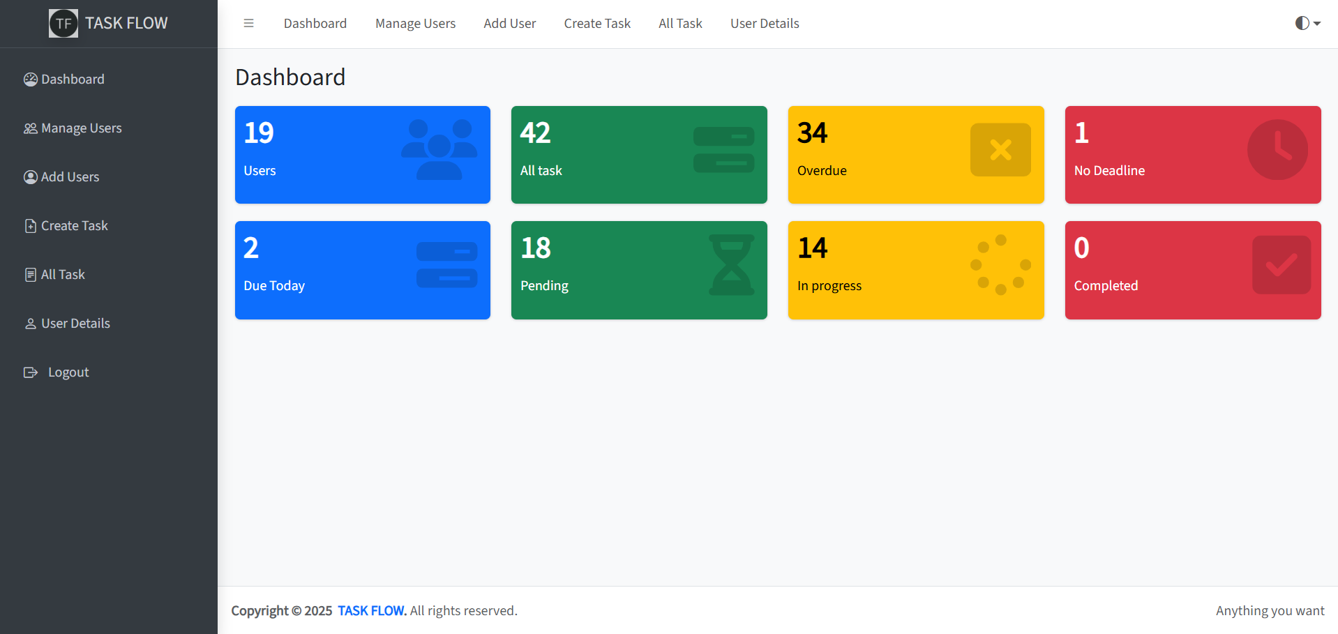



# Introduction

The **TaskFlow** project was conceived to assist users in improving their productivity and motivation. It integrates multiple features that users can interact with once logged in. The project helped us bridge the gap between theoretical learning and actual development using a real tech stack — HTML, CSS, JavaScript (frontend), and PHP(backend).

We followed a structured approach:

* + - Planning & wireframing
    - Frontend UI development
    - Backend
    - Database integration
    - Frontend-backend connectivity
    - Hosting and deployment

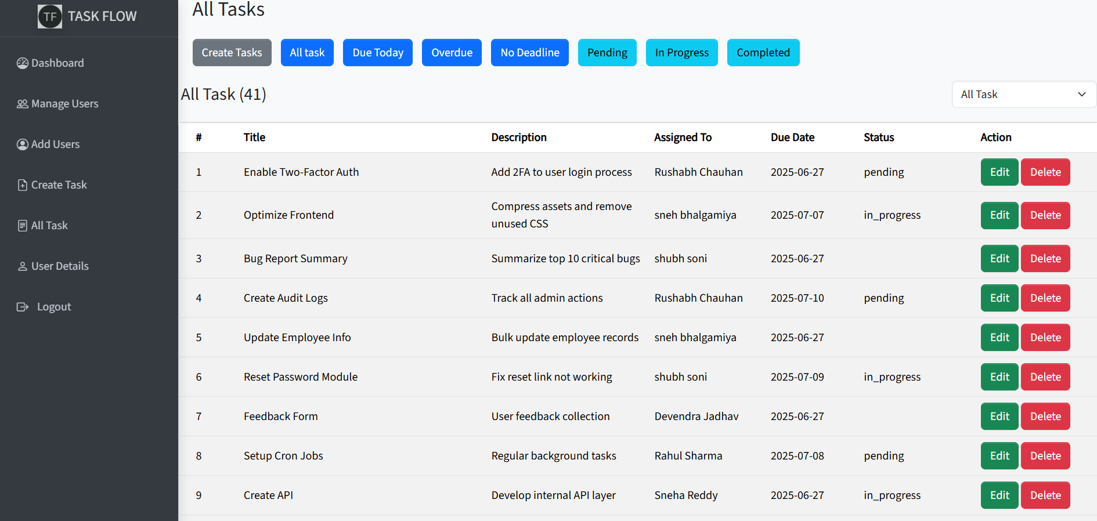

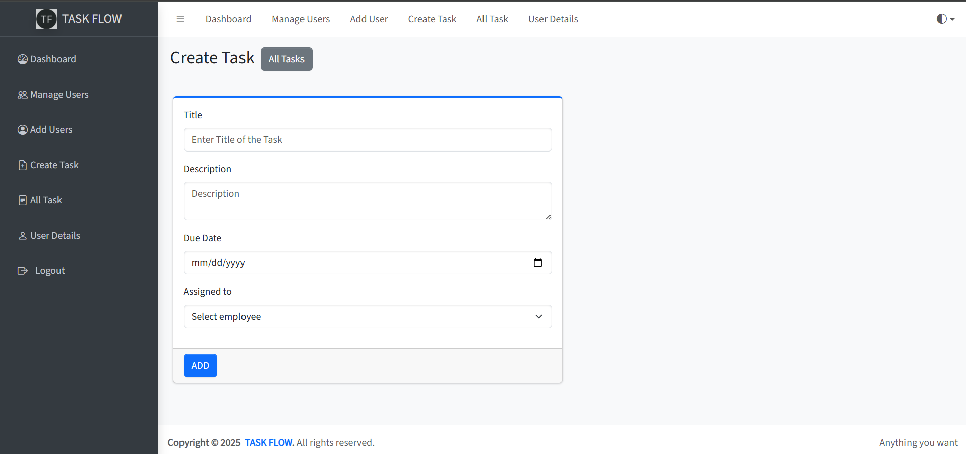



# Purpose

The purpose of the internship and this project is to:

* + - Understand and implement real-time project workflows.
    - Gain hands-on experience with front-end and back-end technologies.
    - Understand project documentation, testing, deployment, and version control.
    - Prepare for future roles in full-stack web development.



# Objective

* + - Build a functional, responsive, and modern web application.
    - Allow Employee to log in, and interact with task Edit task Current process
    - Securely store EmployeeTask and Employee a PHP and MySql backend.
    - Deploy the project for public access using GitHub, Infinityfree(frontend and backend).
    - Practice working in a structured development environment.



# Scope

The scope of the **TaskFlow** project includes:

* + - **Frontend**: UI/UX with Bootstrap, dark/light mode toggle, and animations.
    - **Backend**: PHP and MySql to login Authentication ,Manage DataBase
    - **Tools**: Admin Dashboard, Add-New Employee,List All Task User Detail
    - **Deployment**: Hosting on Infinityfree with DataBased

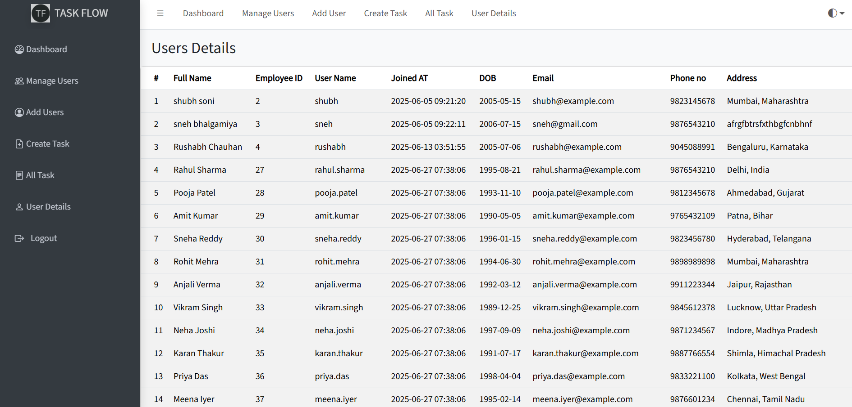

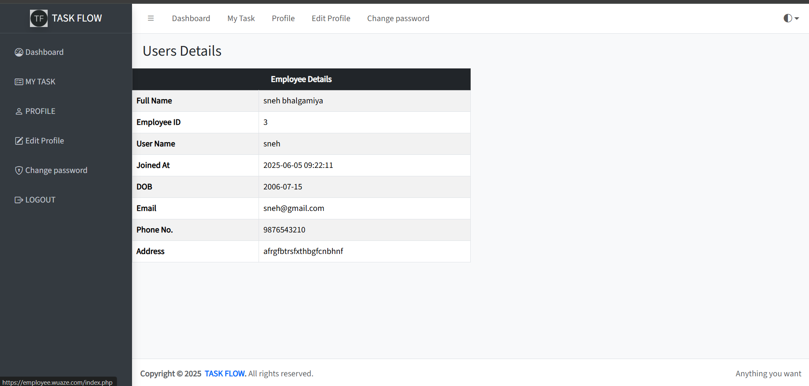



# Technology & Literature Review Frontend Technologies:

* + - **HTML5** – Markup language for page structure.
    - **CSS3 / Bootstrap 5** – Styling and responsive layouts.
    - **JavaScript (ES6)** – Dynamic interactions and API calls.

# Backend Technologies:

* + - PHP–Programming Language and Backend side of the website
    - **MySql**– Local development database.

# Tools & Services:

* + - **GitHub** – Version control and collaboration.
    - **Infinityfree** –Website Deployment

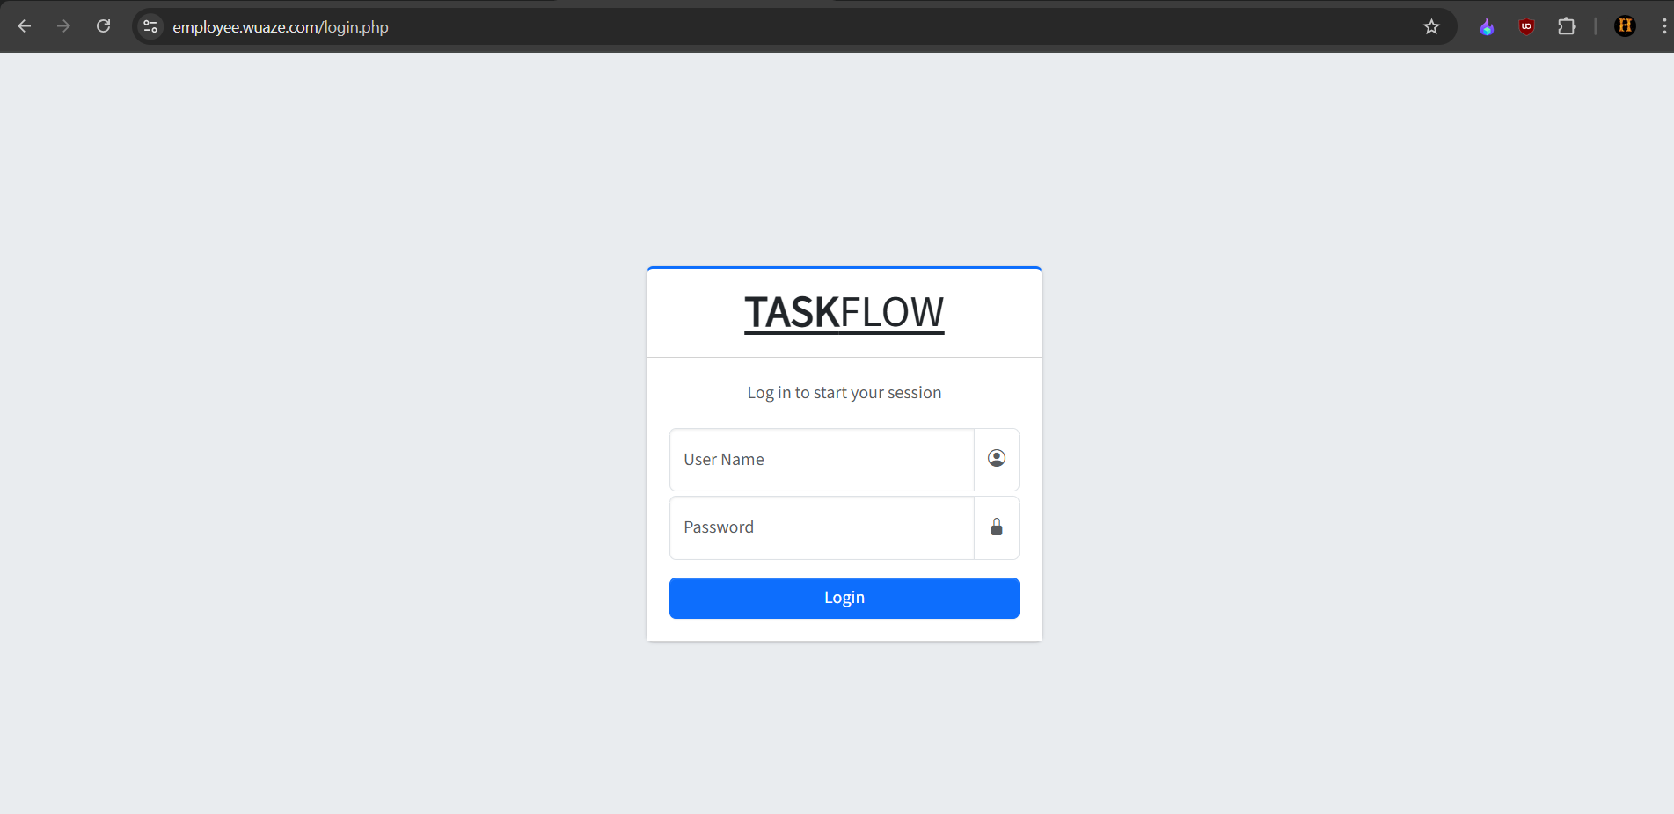

# Chapter 4: Implementation



* 1. **Implementation Environment**

The implementation of the *MotivSync* project was carried out in a full-stack web development environment with the following components:

|  |  |
| --- | --- |
| **Component** | **Technology Used** |
| Frontend Framework | HTML5, CSS3, Bootstrap 5, JS |
| Backend Framework | PHP |
| Database | MySql |
| Version Control | Git & GitHub |
| Hosting Platforms | Infinityfree |

# Implementation Platform

The project was developed and tested on the following platforms:

|  |  |
| --- | --- |
| **Platform** | **Details** |
| Development OS | Windows 11 |
| Browser Used | Google Chrome / Firefox Developer Edition |
| Code Editor | VS Code with Python & HTML extensions |
| Deployment | Infinityfree for frontend, backend and DataBased |

# Process

The development process followed these phases:

# Frontend Development

* + - * Designed using responsive **HTML**, **CSS**, and **Bootstrap 5**
      * Implemented theme toggling (dark/light)
      * Built interactive pages:
        + Dashboard
        + Manage User
        + Add User
        + Create Task
        + All Task
        + User Detail
    1. **Backend Development**
       - * Write a PHP code for Backend side of the web site

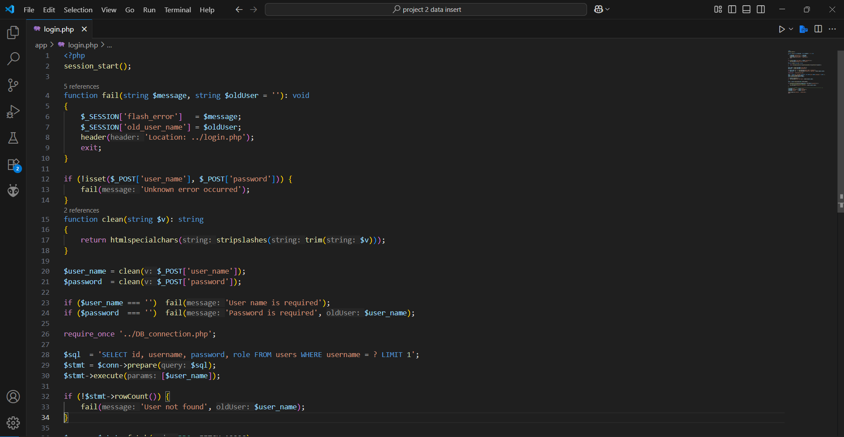

# Database Design

The database schema was minimal, focusing on storing:

* + - * User data (Full Name, username, Password,DOB,Email)
      * Task List (Title, Description, Status, Due Date)

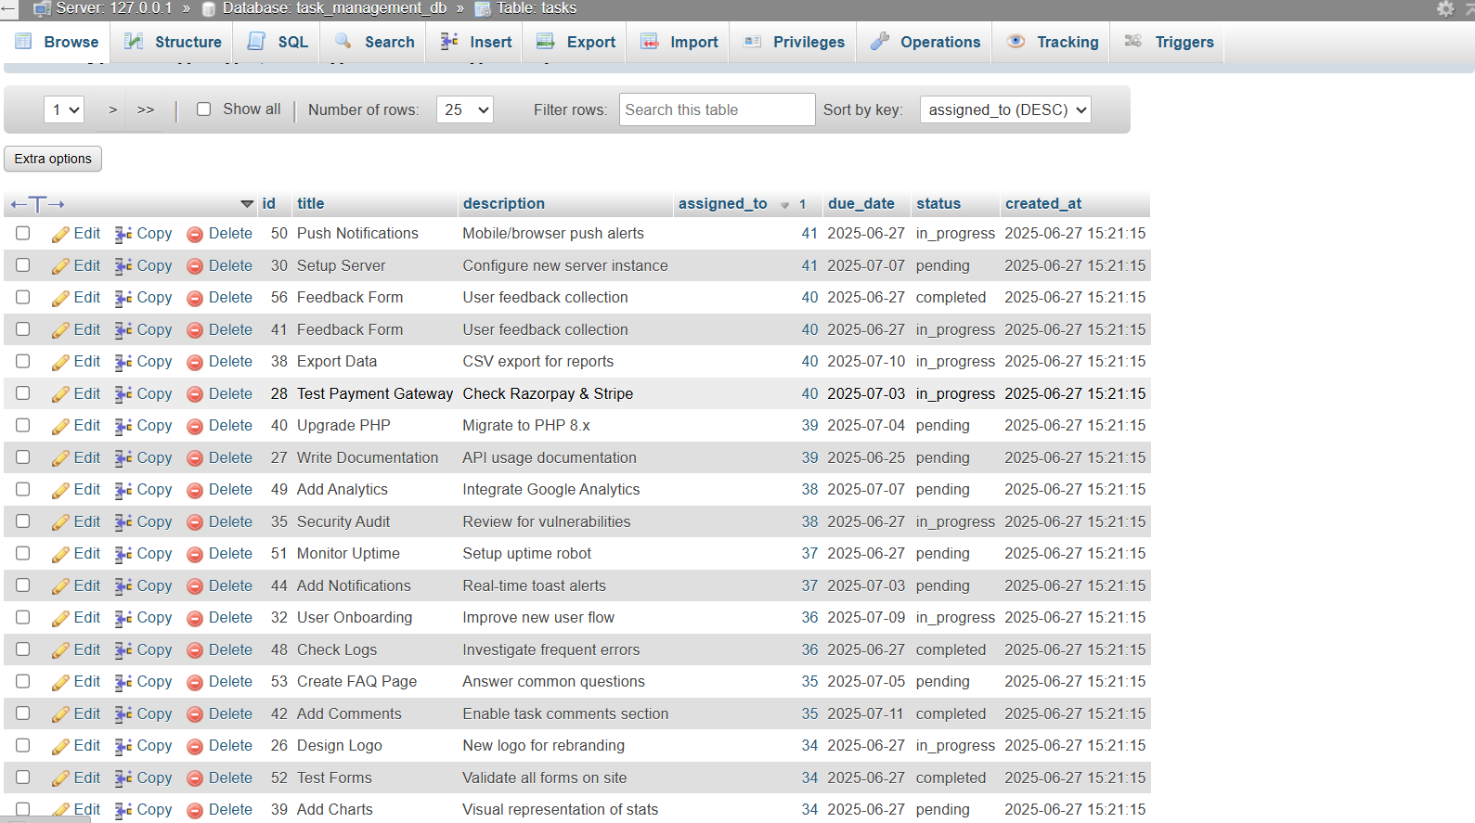

# Result

The complete system was successfully implemented with:

* A live hosted on I**nfinityfree**
* Real-time form submissions stored in the database
* Seamless navigation between pages



**Chapter 5: Conclusion**



* 1. **Conclusion**

The internship at *Arth Consultancy Services* provided a great opportunity to work on a full-fledged web development project. The project named **TaskFlow** aimed to provide a platform for Employee task management. Over the course of 45 days, we implemented both the frontend and backend of the application using modern web technologies including **HTML, CSS, JavaScript, Bootstrap, PHP, MySql**.

Through this internship, we enhanced our understanding of full-stack web development, frontend-backend integration, RESTful communication, and hosting on platforms like I**nfinityfree**. The learning curve was steep but extremely beneficial in strengthening core programming skills and applying theoretical knowledge into real-world solutions.

# Overall Analysis

The overall experience during the internship was enriching and result-oriented. The breakdown of project development phases showed steady progress: